OTA TOTAL ACADEMY NURSERY AND PRIMARY SCHOOL OTA
COMPUTER APPRECIATION PRACTICE
14, Aurella street,
Afobaje Ota,
Ogun State.
09/04/2021.

The Head Teacher,
Ota Total Academy Nursery and Primary School,
Olatunji Street,
Ota.

Dear Sir,
LETTER OF PERMISSION
This letter is to request for permission to be absent from school on the 13th of April, 2021.
This is due to the fact that I will be travelling to my village for our
great-grandfather’s burial ceremony and I am in charge of the feeding of
the visitors that will be travelling down to the village.
I will be very glad if my request is favorably granted.
Thanks.
Yours faithfully,
Alozie Praise.

Below is the picture of the cow for the burial

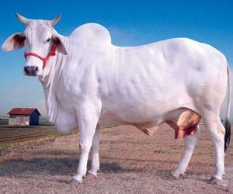

Items needed are:
1. Bags of rice
2. Bags of Semovita
3. Gallon of groundnut oil
4. Pepper
5. Salt
6. Seasoning

